**Enterprise Resource Planning**

*Of*

**ZAB**

**Training User Manual**

**(SV–12.3.0 | MV–1.0.0)**

**For**

**ASIATIC GROUP**

**Production**

**(Fabric Issue, Chemical Issue, Issue To QC, Inspection)**

**Index**

|  |  |  |
| --- | --- | --- |
| **Option No.** | **Option Name** | **Page No.** |
| **Production Part** | | |
|  | Issue To QC/Store | **03** |
|  | Inspection Finished Goods | **06** |
| **Inventory Part** | | |
|  | Fabric Issue (Batch) | **08** |
|  | Chemical Issue (Batch) | **09** |
|  | Chemical Issue (Bulk) | **10** |

**Production Part**

After completing the last process of **Production Process**,

(Without showing Daily Production)

Have to go

**ISSUE TO QC/STORE**

# Issue To QC/Store

|  |  |
| --- | --- |
| **Step 1** | Main Menu (Home Icon) **> Production >**  Issue To QC/Store |
| **Step 2** | Choose the Batch no. /PI no. & then click **Show** |

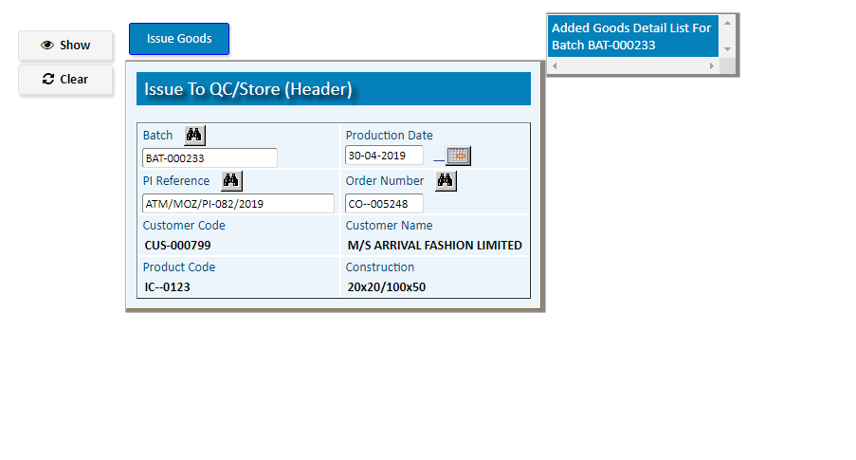

To issue the goods Click **Issue Goods**

1. Pick a Process from the side list of Production Process
2. Pick an Item from the side list of Goods for Issue
3. write qty, unit & Assign the QC store (**05**)
4. Click **Add**

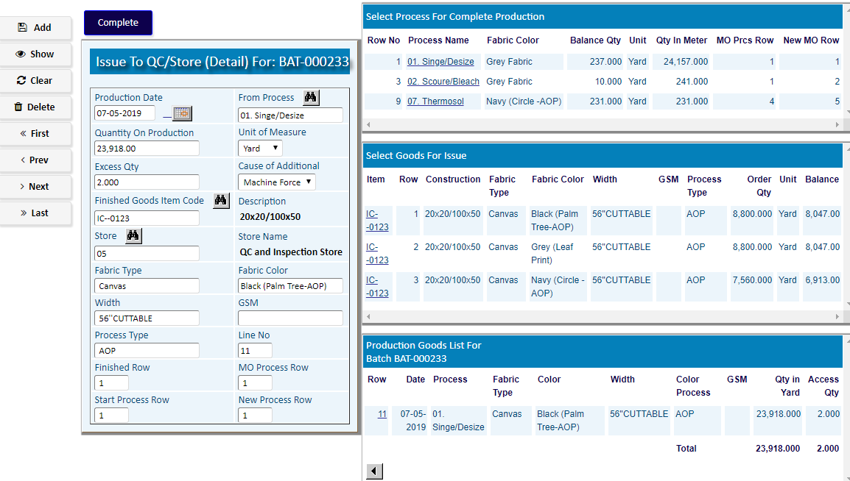

After adding the process & goods, Click **Complete**

After ending

The all **Production** processes

As per Production Manual,

Go to the option

**INSPECTION FINISHED GOODS**

# Inspection Finished Goods

* Inspection Finished Goods Header

|  |  |
| --- | --- |
| **Step 1** | Main Menu (Home Icon) **> Production >**  **Inspection Finished Goods** |
| **Step 2** | Write Order Number, Reference, From Store, To Store |
| **Step 3** | Click **Add** |
| **Step 4** | to Add Products Click **Detail** |

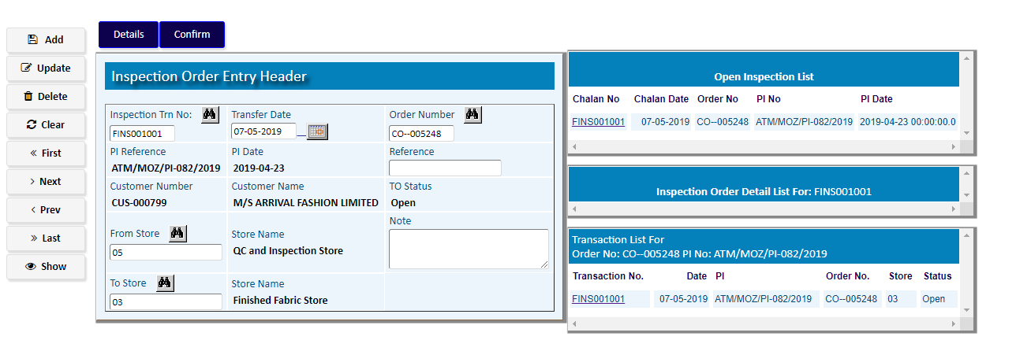

* Inspection Finished Goods Detail

1. Pick a product from the side list of PI Detail
2. Write Qty of Production.
3. Fill the other Info
4. Click **Add**

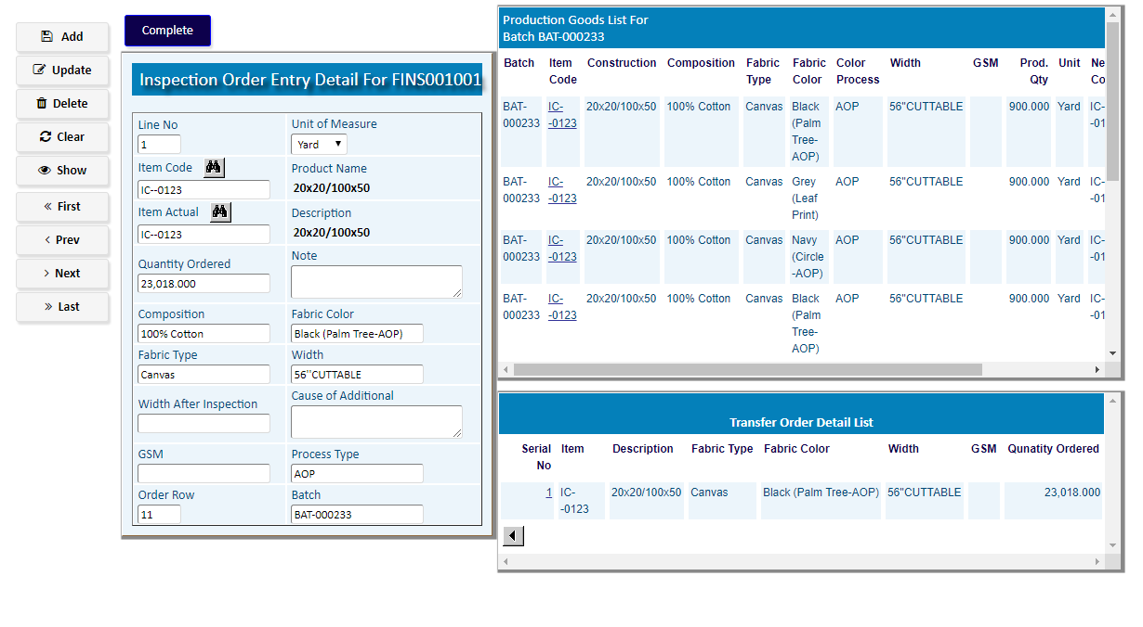

After adding the products, Click **Complete**

To Confirm Click on **Confirm** Button

**Inventory Part**

# Fabric Issue (Batch)

|  |  |
| --- | --- |
| **Step 1** | Main Menu (Home Icon) > Inventory Management  **>**  **Fabric Issue For Production > Fabric Issue (Batch)** |
| **Step 2** | Choose **Requisition** **no**. from side lisr & then click **Show** |
| **Step 3** | click **Check Stock In Hand** |
| **Step 4** | If stock is available, Click **Confirm&Issue** |
| **Result** | Issue has been Confirmed |

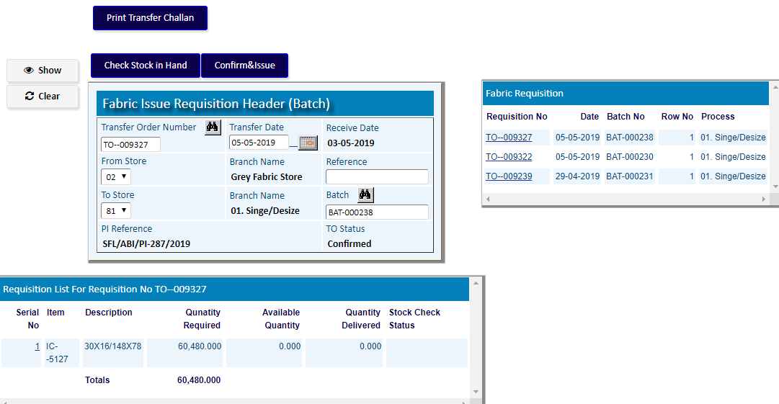

# Chemical Issue (Batch)

|  |  |
| --- | --- |
| **Step 1** | Main Menu (Home Icon) > Inventory Management  **>**  **Chemical Issue For Production > Chemical Issue (Batch)** |
| **Step 2** | Choose **Requisition** **no**. from side lisr & then click **Show** |
| **Step 3** | click **Check Stock In Hand** |
| **Step 4** | If stock is available, Click **Confirm&Issue** |
| **Result** | Issue has been Confirmed |

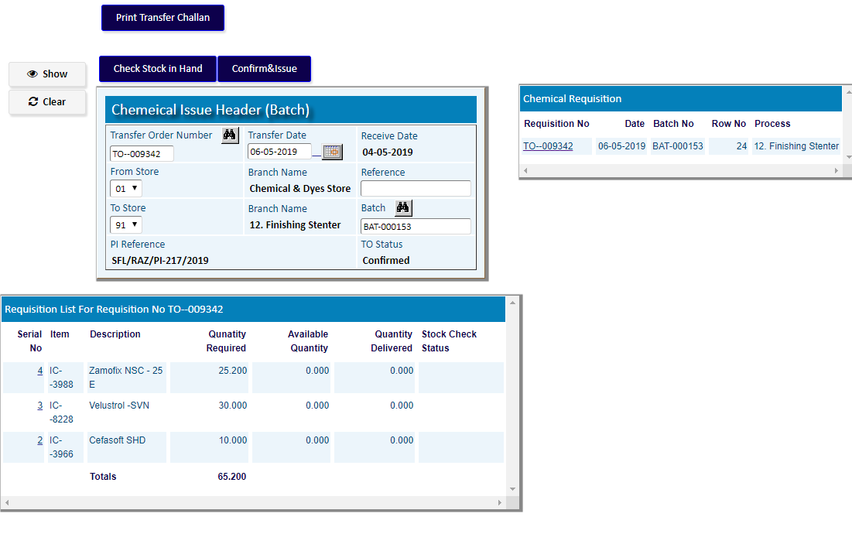

# Chemical Issue (Bulk)

|  |  |
| --- | --- |
| **Step 1** | Main Menu (Home Icon) > Inventory Management  **>**  **Chemical Issue For Production >**  **Chemical Issue (Bulk)** |
| **Step 2** | Choose **Requisition** **no**. from side list & then click **Show** |
| **Step 3** | click **Check Stock In Hand** |
| **Step 4** | If stock is available, Click **Confirm** |
| **Result** | Issue has been Confirmed |

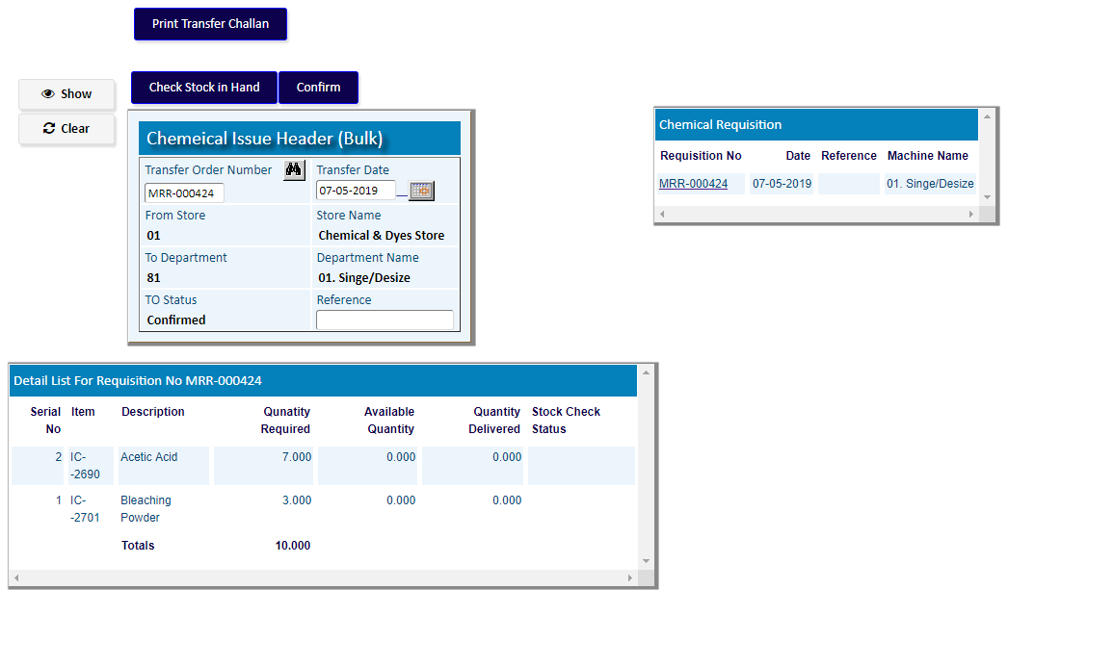

**After the Confirmation of Fabric & Chemical Issue,**

**Go to the Option (As per related Manual of Production Process)**

**Production Process**

(Of Production Module)